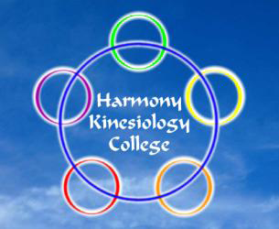
Harmony
Emotional Balancing
Course Level 1

This class introduces methods of assessing and balancing emotional stress on a number of levels – conscious, subconscious and cellular memory levels.

It incorporates in-depth muscle monitoring skills to assess underlying stress issues and associated imbalance and also to evaluate appropriate methods to restore happy, healthy balance.

This class blends powerful healing modalities and skills into a format to promote a deep sense of peace and well-being.
05 & 06 October 2024
£300.00
Early payment option, if paid by 05/09/24 - £270.00
Harmony Kinesiology College
575 Anniesland Road, Scotstounhill, Glasgow G13 1UX
Tel: 0141 959 2042 or 0141 954 1796

Class will run subject to sufficient applicants attending class

...............................detach.....................return form to address below......................detach or email to......................
info@harmonynaturalhealth.co.uk

Harmony Emotional Balancing Course Level 1 - 05 & 06 October 2024

Name

Address

 |  | Postcode
E-mail |  | Mobile
*I wish to pay by Bank Transfer |  | I wish to pay by Card*
Bank Transfer: Co-operative Bank  Account Name: James Currie |  | Account: 68051185 | Sort Code: 08-92-50
* If you would like to pay by debit or credit card, please phone 0141 959 2042

Signed |  | Date

Return to: Harmony College, 575 Anniesland Rd, Glasgow G13 1UX

